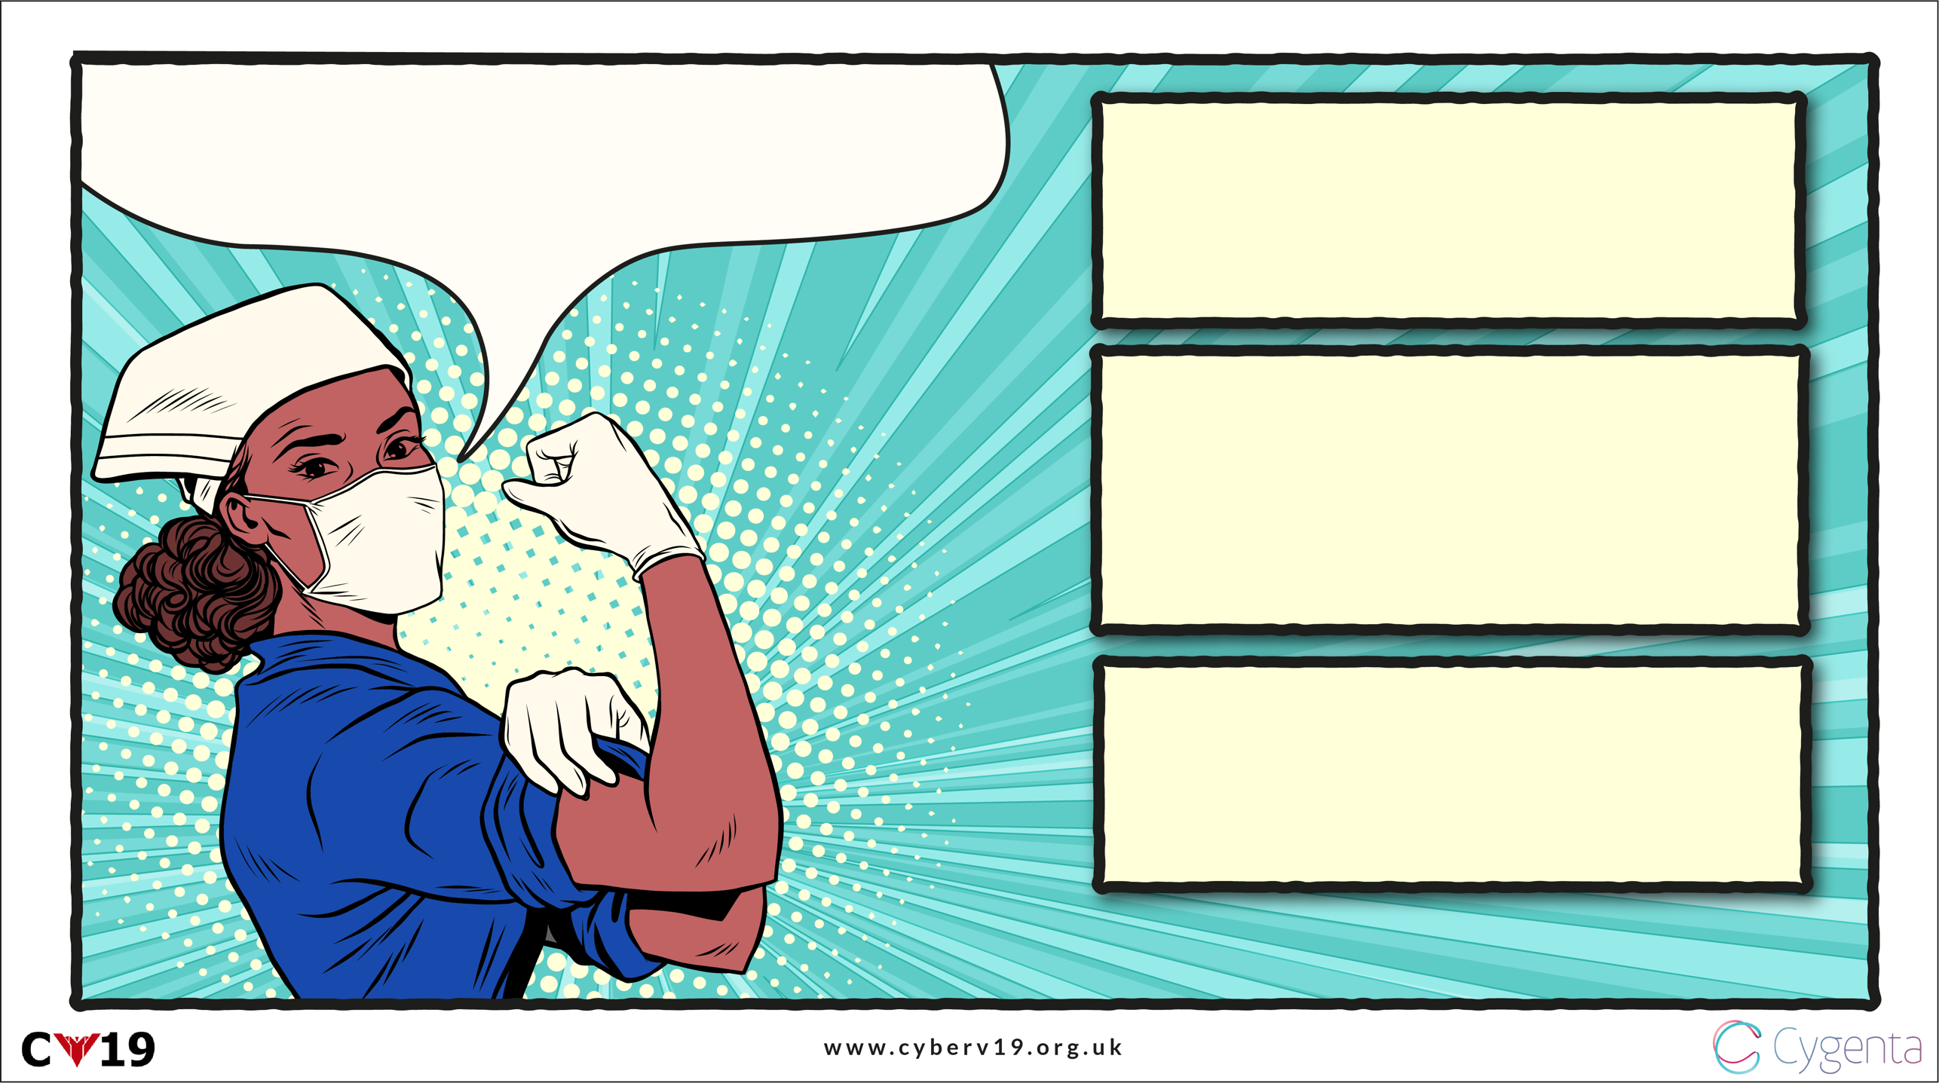

PROTECT YOUR PPE

WEAR YOUR ID BADGES IN, NEVER OUT

LOG OFF COMPUTER

Physical Security:

Like Everything Else, You’ve got it Covered

LOCK IT, DON’T LEAVE IT

Thieves are targeting this precious resource

Your colleagues need to know who you are, but criminals don’t

Don’t leave your devices open to anyone